Activity 1.1.2 Design Principles and Elements

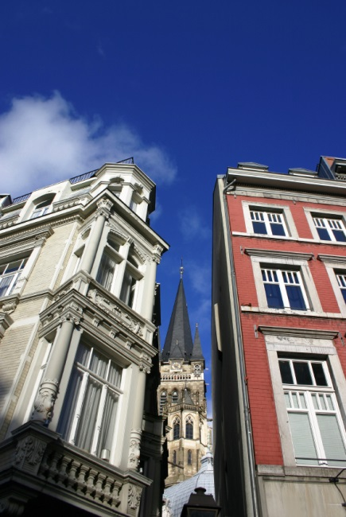
Introduction
Have you ever noticed how buildings of similar size and shape can have completely different visual effects? Architects, like artists, must understand the elements and principles of design and how they affect the visual impact of the building on a viewer. Whether it is the intent of the architect to create a feeling of strength and stability or to create an unusual form that will elicit a double-take from the public, the elements and principles of design can be used to manipulate the intellectual and emotional reactions of the people who see and use the building.

Equipment
- Principles and Elements of Design Applied to Architecture presentation notes

Procedure
In this activity you will identify design elements and principles as they pertain to images of structures.

For each of the following, choose all the elements of design and all principles of design that you feel is most prominent in the image and then justify your choice.

Word Bank
Balance | Form | Rhythm | Texture
Color | Line | Shape | Unity
Emphasis | Proportion/Scale | Space | Value

6 Visual Design Elements | 7 Visual Design Principles
- Line  - Color  - Form and Shape  - Spaces  - Texture  - Value | - Balance  - Rhythm  - Emphasis  - Proportion and scale  - Movement  - Contrast  - Unity

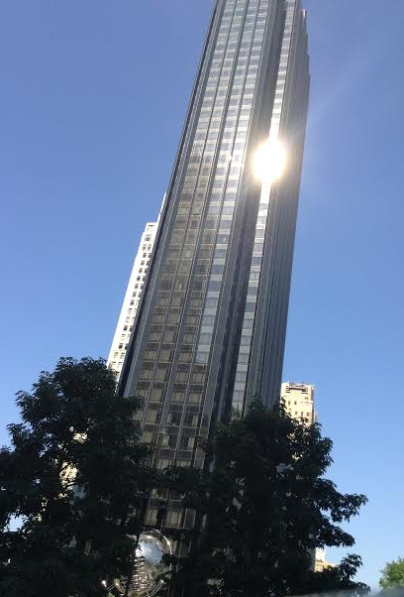

Element of Design:
- Line: This building has vertical lines because my attention is brought to the height of the building.
- Texture: It has a smooth texture due to it being made up of glass and reflecting light.

Principle of Design:
- Proportion & Scale: Compared to the buildings behind the structure, I can tell that this building was designed to draw away from surrounding buildings because it is higher.
- Balance: Vertical balances because the building is tall.
- Unity: The same glass is used.

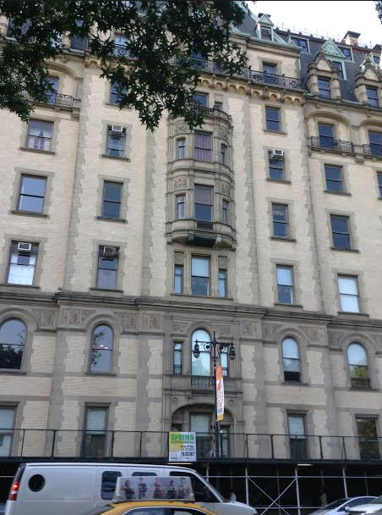

Element of Design:
- Color: This structure has patina from when copper oxidized. The patina color brings the eye up to the roof.
- Line: Horizontal because the building is wide.
- Texture: Rough because it is made up of bricks.

Principle of Design:
- Emphasis: In the middle of the building, there is a texture feature which highlights the entrance. The round shape contrasts with the angular edges.
- Balance: Symmetrical and formal balance due to what you see on one half is on the other.
- Rhythm: Random because on each level there are different widths or arches.
- Unity: The same windows are used.

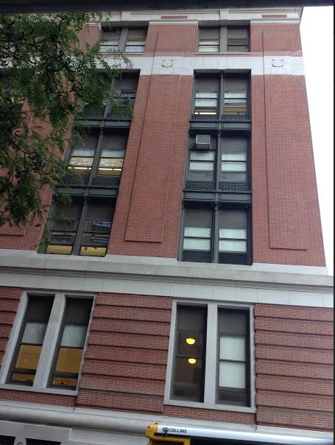

Element of Design:
- Color: The red brick with the white details brings interest. Red is a warm color which tends to cause excitement.
- Texture: Rough the bricks have an uneven texture and are layered sometimes higher than others.
- Shape: I see rectangular shapes made from the bricks.

Principle of Design:
- Rhythm: The windows are all different dimensions on each level.
- Contrast: There are different depths of how the bricks were layered adding texture.

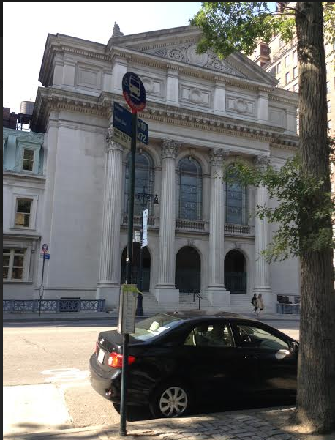

Element of Design:
- Shape: There is a 2-dimensional shape of a triangle on the top.
- Form & Shape: The columns are cylindrical.
- Line: Vertical lines with the height and use of columns.

Principle of Design:
- Balance: This building is symmetrical and has vertical balance.
- Emphasis: There is emphasis on the height by using proportion of the columns compared to the building itself.

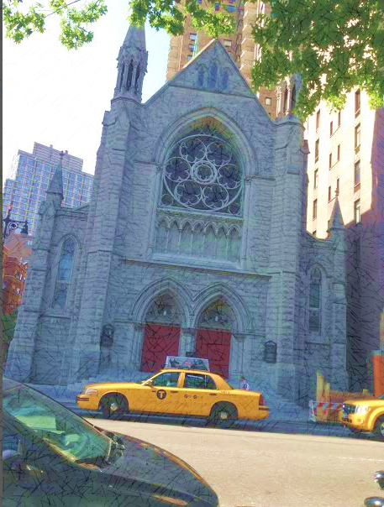

Element of Design:
- Texture: The church has a rough texture that absorbs light.
- Color: The red door adds warm feeling.
Form & Shape: There is a 3-D prism with the triangular column.

Principle of Design:
- Balance: The center stain class design has radial balance because the design elements radiate outward from the center, creating an almost flower-like look. Also, symmetrical balance is there both sides are formal.
- Contrast: There is contrast between the rough stone and smooth glass.
- Rhythm: Random rhythm because different windows are used.

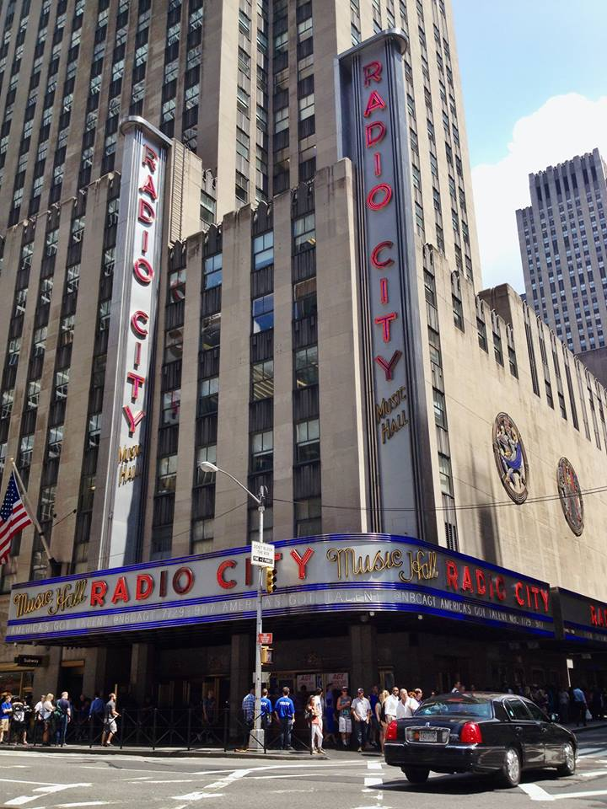

Element of Design:
- Line: This building is drawing attention upwards, with the rigidness of the windows.
- Color: Red is a warm color.
- Form & Shape: 3-D rectangular signs.

Principle of Design:
- Emphasis: The signs are vertical and show emphasis to the long height.
- Balance: Informal balance

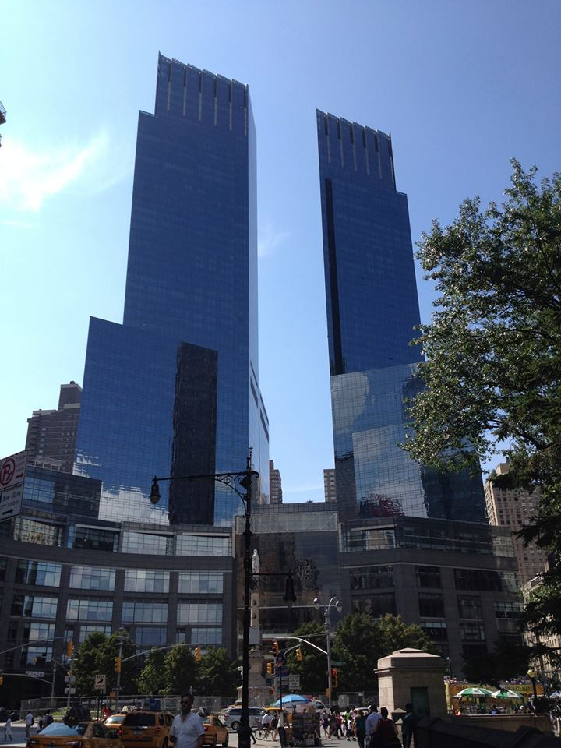

Element of Design:
- Texture: The building is made up of glass windows, reflecting sunlight.
- Line: Vertical lines due to height.

Principle of Design:
- Rhythm: The buildings have a graduated rhythm. The side of the building is increasing each time.
- Balance: Horizontal balance because the buildings mirror one another.

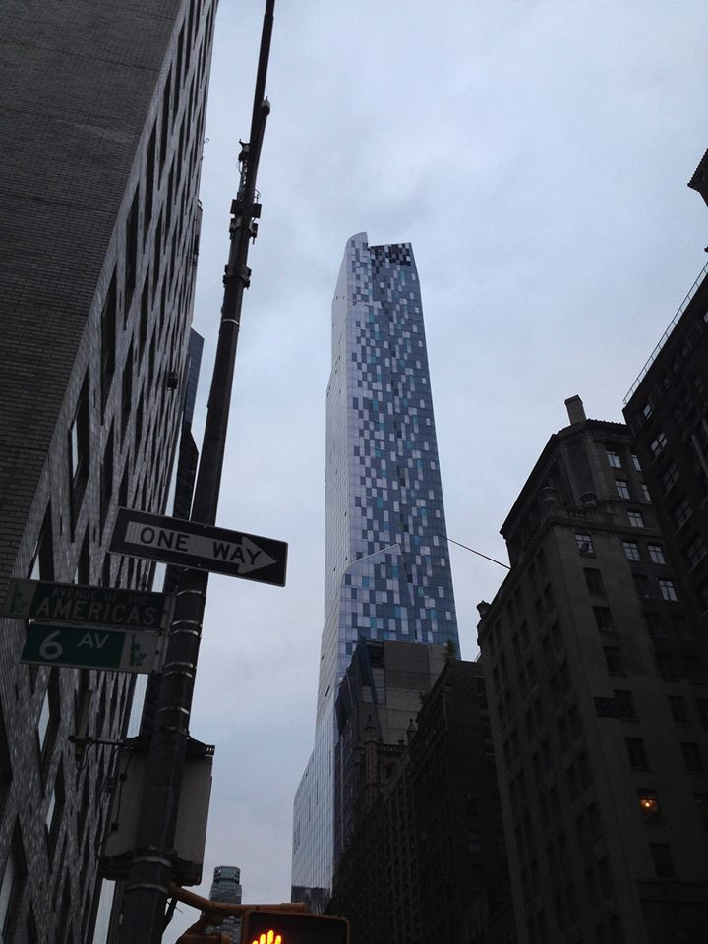

Element of Design:
- Line: This skyscraper shows vertical lines due to its great height.
- Texture: Smooth because the building is made up of glass windows that reflect light.
- Tint: There is shade because of the lighter and darker windows.

Principle of Design:
- Contrast: The building has contrast between the noticeably lighter glass windows and the darker.
- Balance: Asymmetrical and informal balance on the top the building is rugged.
- Rhythm: There is random rhythm the lighter and darker windows have no particular pattern.

Conclusion

- In what way do certain elements or principles identify the time period in which a structure was created?

I can tell if a building is modern if it has class and if a building is made up of stones or brick on most occasions it is a dated building. That is attributed to texture. Modern buildings like reflecting light and are higher (vertical lines), while much older buildings have more horizontal lines and absorb light.

- What factors might account for an incorrect identification?

The quality of the picture can cause incorrect identification, because sometimes the texture is not very visible. Also, depending on the sizing of the picture a building can appear taller or squattier, therefore misclassifying the lines.

- Describe an example of a way that design principles and elements could impact the function of a building.

All buildings serve different purposes. Churches would have more horizontal lines because they want to convey a feeling of calmness, on the other hand, a business building would want to let people know they are strong and have vertical lines. Churches would also want to attract more people, so they would emphasize their building using, texture, forms, shape and color.

