Layers of an Exterior Wall and it’s Thickness
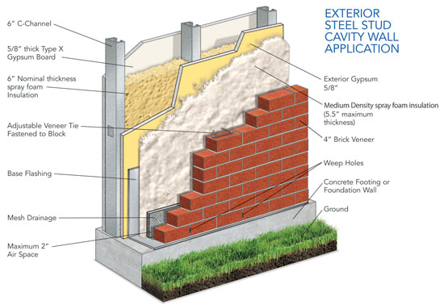
Materials | Thickness
Brick Veneer | 4”
Mesh Drainage | 1”
Medium Density Spray Foam Insulation | 5.5”
Base Flashing | ⅕”
Exterior Gypsum | ⅝”
Nominal Thickness Spray Foam Insulation | 6”
Thick Type X Gypsum Board | ⅝”
C-Channel | 6”

